**Bluetooth Tutorial:**

<https://www.tutorialspoint.com/android/android_bluetooth.htm>

Among many ways, Bluetooth is a way to send or receive data between two different devices. Android platform includes support for the Bluetooth framework that allows a device to wirelessly exchange data with other Bluetooth devices.

Android provides Bluetooth API to perform these different operations.

Scan for other Bluetooth devices

Get a list of paired devices

Connect to other devices through service discovery

Android provides BluetoothAdapter class to communicate with Bluetooth. Create an object of this calling by calling the static method getDefaultAdapter(). Its syntax is given below.

private BluetoothAdapter BA;

BA = BluetoothAdapter.getDefaultAdapter();

In order to enable the Bluetooth of your device, call the intent with the following Bluetooth constant ACTION\_REQUEST\_ENABLE. Its syntax is.

Intent turnOn = new Intent(BluetoothAdapter.ACTION\_REQUEST\_ENABLE);

startActivityForResult(turnOn, 0);

Apart from this constant, there are other constants provided the API , that supports different tasks. They are listed below.

|  |  |
| --- | --- |
| **Sr.No** | **Constant & description** |
| 1 | **ACTION\_REQUEST\_DISCOVERABLE**  This constant is used for turn on discovering of bluetooth |
| 2 | **ACTION\_STATE\_CHANGED**  This constant will notify that Bluetooth state has been changed |
| 3 | **ACTION\_FOUND**  This constant is used for receiving information about each device that is discovered |

Once you enable the Bluetooth , you can get a list of paired devices by calling getBondedDevices() method. It returns a set of bluetooth devices. Its syntax is.

private Set<BluetoothDevice>pairedDevices;

pairedDevices = BA.getBondedDevices();

Apart form the parried Devices , there are other methods in the API that gives more control over Blueetooth. They are listed below.

|  |  |
| --- | --- |
| **Sr.No** | **Method & description** |
| 1 | **enable()**  This method enables the adapter if not enabled |
| 2 | **isEnabled()**  This method returns true if adapter is enabled |
| 3 | **disable()**  This method disables the adapter |
| 4 | **getName()**  This method returns the name of the Bluetooth adapter |
| 5 | **setName(String name)**  This method changes the Bluetooth name |
| 6 | **getState()**  This method returns the current state of the Bluetooth Adapter. |
| 7 | **startDiscovery()**  This method starts the discovery process of the Bluetooth for 120 seconds. |

## Example

This example provides demonstration of BluetoothAdapter class to manipulate Bluetooth and show list of paired devices by the Bluetooth.

To experiment with this example , you need to run this on an actual device.

|  |  |
| --- | --- |
| **Steps** | **Description** |
| 1 | You will use Android studio to create an Android application a package com.example.sairamkrishna.myapplication. |
| 2 | Modify src/MainActivity.java file to add the code |
| 3 | Modify layout XML file res/layout/activity\_main.xml add any GUI component if required. |
| 4 | Modify AndroidManifest.xml to add necessary permissions. |
| 5 | Run the application and choose a running android device and install the application on it and verify the results. |

Here is the content of **src/MainActivity.java**

package com.example.sairamkrishna.myapplication;

import android.app.Activity;import android.bluetooth.BluetoothAdapter;import android.bluetooth.BluetoothDevice;

import android.content.Intent;import android.os.Bundle;import android.view.View;

import android.widget.ArrayAdapter;import android.widget.Button;import android.widget.ListView;

import android.widget.Toast;import java.util.ArrayList;import java.util.Set;

public class MainActivity extends Activity {

Button b1,b2,b3,b4;

private BluetoothAdapter BA;

private Set<BluetoothDevice>pairedDevices;

ListView lv;

@Override

protected void onCreate(Bundle savedInstanceState) {

super.onCreate(savedInstanceState);

setContentView(R.layout.activity\_main);

b1 = (Button) findViewById(R.id.button);

b2=(Button)findViewById(R.id.button2);

b3=(Button)findViewById(R.id.button3);

b4=(Button)findViewById(R.id.button4);

BA = BluetoothAdapter.getDefaultAdapter();

lv = (ListView)findViewById(R.id.listView);

}

public void on(View v){

if (!BA.isEnabled()) {

Intent turnOn = new Intent(BluetoothAdapter.ACTION\_REQUEST\_ENABLE);

startActivityForResult(turnOn, 0);

Toast.makeText(getApplicationContext(), "Turned on",Toast.LENGTH\_LONG).show();

} else {

Toast.makeText(getApplicationContext(), "Already on", Toast.LENGTH\_LONG).show();

}

}

public void off(View v){

BA.disable();

Toast.makeText(getApplicationContext(), "Turned off" ,Toast.LENGTH\_LONG).show();

}

public void visible(View v){

Intent getVisible = new Intent(BluetoothAdapter.ACTION\_REQUEST\_DISCOVERABLE);

startActivityForResult(getVisible, 0);

}

public void list(View v){

pairedDevices = BA.getBondedDevices();

ArrayList list = new ArrayList();

for(BluetoothDevice bt : pairedDevices) list.add(bt.getName());

Toast.makeText(getApplicationContext(), "Showing Paired Devices",Toast.LENGTH\_SHORT).show();

final ArrayAdapter adapter = new ArrayAdapter(this,android.R.layout.simple\_list\_item\_1, list);

lv.setAdapter(adapter);

}}

Here is the content of **activity\_main.xml**

Here abc indicates about logo of tutorialspoint.

<?xml version="1.0" encoding="utf-8"?><RelativeLayout xmlns:android="http://schemas.android.com/apk/res/android"

xmlns:tools="http://schemas.android.com/tools"

android:layout\_width="match\_parent"

android:layout\_height="match\_parent"

android:paddingLeft="@dimen/activity\_horizontal\_margin"

android:paddingRight="@dimen/activity\_horizontal\_margin"

android:paddingTop="@dimen/activity\_vertical\_margin"

android:paddingBottom="@dimen/activity\_vertical\_margin"

tools:context=".MainActivity"

android:transitionGroup="true">

<TextView android:text="Bluetooth Example"

android:layout\_width="wrap\_content"

android:layout\_height="wrap\_content"

android:id="@+id/textview"

android:textSize="35dp"

android:layout\_alignParentTop="true"

android:layout\_centerHorizontal="true" />

<TextView

android:layout\_width="wrap\_content"

android:layout\_height="wrap\_content"

android:text="Tutorials point"

android:id="@+id/textView"

android:layout\_below="@+id/textview"

android:layout\_centerHorizontal="true"

android:textColor="#ff7aff24"

android:textSize="35dp" />

<ImageView

android:layout\_width="wrap\_content"

android:layout\_height="wrap\_content"

android:id="@+id/imageView"

android:src="@drawable/abc"

android:layout\_below="@+id/textView"

android:layout\_centerHorizontal="true"

android:theme="@style/Base.TextAppearance.AppCompat" />

<Button

android:layout\_width="wrap\_content"

android:layout\_height="wrap\_content"

android:text="Turn On"

android:id="@+id/button"

android:layout\_below="@+id/imageView"

android:layout\_toStartOf="@+id/imageView"

android:layout\_toLeftOf="@+id/imageView"

android:clickable="true"

android:onClick="on" />

<Button

android:layout\_width="wrap\_content"

android:layout\_height="wrap\_content"

android:text="Get visible"

android:onClick="visible"

android:id="@+id/button2"

android:layout\_alignBottom="@+id/button"

android:layout\_centerHorizontal="true" />

<Button

android:layout\_width="wrap\_content"

android:layout\_height="wrap\_content"

android:text="List devices"

android:onClick="list"

android:id="@+id/button3"

android:layout\_below="@+id/imageView"

android:layout\_toRightOf="@+id/imageView"

android:layout\_toEndOf="@+id/imageView" />

<Button

android:layout\_width="wrap\_content"

android:layout\_height="wrap\_content"

android:text="turn off"

android:onClick="off"

android:id="@+id/button4"

android:layout\_below="@+id/button"

android:layout\_alignParentLeft="true"

android:layout\_alignParentStart="true" />

<ListView

android:layout\_width="wrap\_content"

android:layout\_height="wrap\_content"

android:id="@+id/listView"

android:layout\_alignParentBottom="true"

android:layout\_alignLeft="@+id/button"

android:layout\_alignStart="@+id/button"

android:layout\_below="@+id/textView2" />

<TextView

android:layout\_width="wrap\_content"

android:layout\_height="wrap\_content"

android:text="Paired devices:"

android:id="@+id/textView2"

android:textColor="#ff34ff06"

android:textSize="25dp"

android:layout\_below="@+id/button4"

android:layout\_alignLeft="@+id/listView"

android:layout\_alignStart="@+id/listView" />

</RelativeLayout>

Here is the content of **Strings.xml**

<resources>

<string name="app\_name">My Application</string></resources>

Here is the content of **AndroidManifest.xml**

<?xml version="1.0" encoding="utf-8"?><manifest xmlns:android="http://schemas.android.com/apk/res/android"

package="com.example.sairamkrishna.myapplication" >

<uses-permission android:name="android.permission.BLUETOOTH"/>

<uses-permission android:name="android.permission.BLUETOOTH\_ADMIN"/>

<application

android:allowBackup="true"

android:icon="@mipmap/ic\_launcher"

android:label="@string/app\_name"

android:theme="@style/AppTheme" >

<activity

android:name=".MainActivity"

android:label="@string/app\_name" >

<intent-filter>

<action android:name="android.intent.action.MAIN" />

<category android:name="android.intent.category.LAUNCHER" />

</intent-filter>

</activity>

</application></manifest>

Let's try to run your application. I assume you have connected your actual Android Mobile device with your computer. To run the app from Android studio, open one of your project's activity files and click Run IMG_256 icon from the tool bar.If your Bluetooth will not be turned on then, it will ask your permission to enable the Bluetooth.

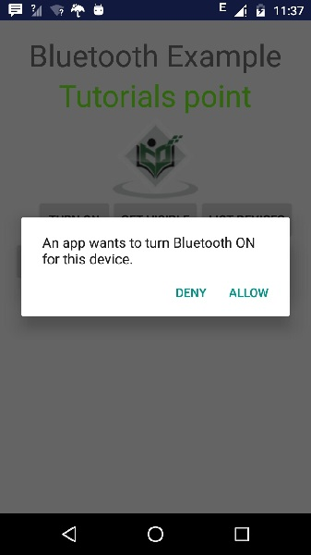

Now just select the Get Visible button to turn on your visibility. The following screen would appear asking your permission to turn on discovery for 120 seconds.

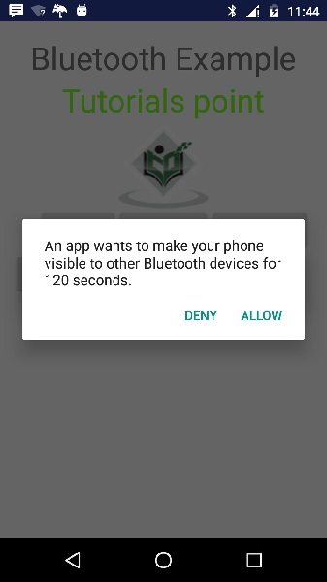

Now just select the List Devices option. It will list down the paired devices in the list view. In my case , I have only one paired device. It is shown below.

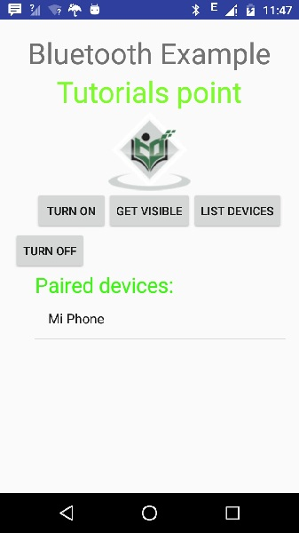

Now just select the Turn off button to switch off the Bluetooth. Following message would appear when you switch off the bluetooth indicating the successful switching off of Bluetooth.

